Table of Contents

1. Introduction 2

2. Vision Statement 2

3. Business Overview 3

3.1 Market Analysis 3

3.1.1 Open Source Tools 3

3.1.2 Commercial tools 3

3.2 Target Users 4

3.3 Target Customers 5

4. Product Details 6

4.1 Product Overview 6

4.2 Product Features 7

5. System Constraints 11

5.1 Supported OSes 11

5.2 Supported Hardware 11

6. Distribution Model & Monetization 11

KMS Technology, Inc. • 375 Northbridge RD, Suite 520, Sandy Springs, GA 30350, USA • Tel: (770) 359-0050 • Fax: (770) 359-0051 • [www.kms-technology.com](http://www.kms-technology.com)

KMS Technology, Inc. • 6098 Kingsmill Terrace, Dublin, CA 94568, USA • Tel: (925) 828-1906 • Fax: (925) 245-9058 • [www.kms-technology.com](http://www.kms-technology.com)

# Introduction

Katalon is an automated functional and regression testing platform that provides the user ability to implement full automated testing solutions for their application projects with reduced and minimal engineering and programming skill requirements. It is designed to be used both by experts in test automation as well as those that are new to the concept.

# Vision Statement

|  |  |
| --- | --- |
| **For (target customer)** | Clients who need to rapidly deploy test automation and who do not want automation only to be executed by engineers. |
| **Who (statement of the need of opportunity)** | Katalon is an accelerator for test automation engagements. Target customers include both novice and mature consumers\users of test automation. Target users include both technical and non-technical testers. |
| **Product Category** | Automated testing frameworks and accelerators |
| **That (key benefit)** | * Unlike other test automation frameworks, Katalon will come “out of the box” capable of being used * Easy start with minimal scripting skills using keyword-driven approaches but unlimited growth opportunity to solve complex problem using scripting alternative * High productive platform with modern UIs, real-time team collaboration IDE * Ability to generate automated test cases skeleton/design from existing manual test cases to speed up the adoption of automated test from existing manual test solutions * Integration to Test Case Management (TCM) and Application Lifecycle Management (ALM) tools, with a high preference to qTest integration * Ability to automated directly from eXplorer scripts |
| **Unlike (primary competitive alternative)** | * Flexibility of either on-premise or SaaS model is unique among all consulting companies * Treating it as a supportable product with versions and licenses is unique in the industry * Focused on Agile testing approaches compatible with TDD, Automated first, automated unit test, or even mixed approaches * Easy to start with inexperience scripting testers with keyword-driven approach but increase unlimited capability solving complexity problem with scripted or mix approach. * Unique multi-platform (Windows, Mac, Linux) and high productive IDE with great team collaboration features * Possible monetization via “Big Data” gathering for analytics purpose * Affordable price, can be free with consulting services or sold stand alone * Can be given to clients without the need for ongoing source code access or maintenance by clients |
| **Differentiation** | * Minimize deployment and development effort (convenient composer & work-flow, generate automated test case from manual steps) * Facilitate teamwork (version control, team collaboration utility) * Central test management (build a dedicated server or incorporate with qTest as a unified solution) * Customizable & extensible * Online update sites (update hot fixes for issues easily & quickly) * Execution scheduling & planning for long run * The most FREE comprehensive automation studio in the market * Innovative features for enterprise solutions including:   + 100% buy-as-you-go automation management including testing lab   + Big data gathering analytics for quality monitoring and enhancements   + Measurement of test case’s effectiveness for ROI improvements   + Leverage community contributions for boosting the development of test scripts (via Katalon’s Store) |

# Business Overview

## Market Analysis

### Open Source Tools

To be completed

### Commercial tools

The table below is node-locked license price list for existing vendors. Floating user license is usually a bit higher than node-locked. The price is for 1-year subscription.

|  |  |  |
| --- | --- | --- |
| Tool | Reference Price | Competitor? |
| Squish GUI Tester | **$9,315** |  |
| HP Unified Functional Testing | **$8,000** |  |
| Testing Anywhere | **$7,000** |  |
| Rational Functional Tester | **$6,820** |  |
| SilkTest | **$4,500** | **x** |
| QF-Test | **$2,693** | **x** |
| Ranorex Studio | **$2,687** | **x** |
| Telerik Test Studio Functional | **$2,499** | **x** |
| TestComplete | **$1,999** | **x** |
| QA Wizard Pro | **$1,495** | **x** |
| Usetrace | **$1,080** |  |
| RIATest | **$499** |  |
| TestCafe | **$499** |  |
| Sahi Pro | **$495** |  |
| iMacros | **$495** |  |
| RoutineBot | **$495** |  |
| vTest | **$295** |  |
| WinTask | **$249** |  |
| PureTest | **$199** |  |
| Netvantage Functional Tester | **$195** |  |
| Badboy | **$45** |  |
| SeeTest |  |  |
| ZAP |  |  |
|  |  |  |

The price list is divided into 3 groups:

* Low: Below $1k
* Medium: $1k to 5k
* High: Above $5k

And the Katalon will be swimming in the Medium group pool.

## Target Users

* Non-scripting experienced and automated test engineers

## Target Customers

* Company who wants to do automated testing for their software products
* Especially, company who wants to leverage non-scripting skilled testers to do automation
* Target monetized customers would be enterprise companies not ISVs

# Product Details

## Product Overview

The core product of Katalon is Katalon Studio. The idea behind Katalon Studio is that it includes an environment in which the test automation resource can build and execute automated tests in a rapid model based on a keyword driven framework. Katalon Studio will be installed with a number of basic built-in keywords for traditional and standard functions needed in test automation and the value of its model is that as new functions are created, all Katalon engagements and users gain the benefit of this ever growing library of reusable artifacts.

Moreover, additional keywords will also be developed to further serve the need of doing automation testing for various types of applications in various environments. These additional keywords will be grouped into different plugins that can be plugged into Katalon Studio as needed. Each plugin will contain a list of pre-built keywords specifically used for testing application falling under the following types:

* Web Applications – 1st priority
* Mobile Native Applications – 2nd priority
  + iOS
  + Android
* Desktop Applications – 3rd priority
  + WPF
  + Java-based desktop applications
  + .NET-based desktop applications
  + Mac (???)

All the Katalon Studio Plugins are kept in Katalon Store. Katalon Store takes the form of an online store, where the users can browse through different plugin categories, view information about each plugin (such as reviews or ratings), and acquire the plugin (including plugin purchase if the plugin is provided with some cost). Moreover, it also allows the user from the community to contribute to this online store by submitting and sharing prospective plugins. It is required that the submission of prospective plugin goes through an approval process. And the owner of prospective plugin can choose to share it either with or without cost.

Another asset of Katalon is Katalon Agent. The idea behind Katalon Agent is that it will provide the capability to execute automated test cases in the testing workstations without having to install Katalon Studio.

Furthermore, Katalon also provides an additional tool – Katalon Operation Management - to allow the user to plan, manage and generate reports on the status of testing activities performed within Katalon platform. This is a web application which generally allows the user to schedule the execution of automated tests, gather execution data from automated tests for data analysis purpose later on.

In summary, Katalon platform can be depicted as below:

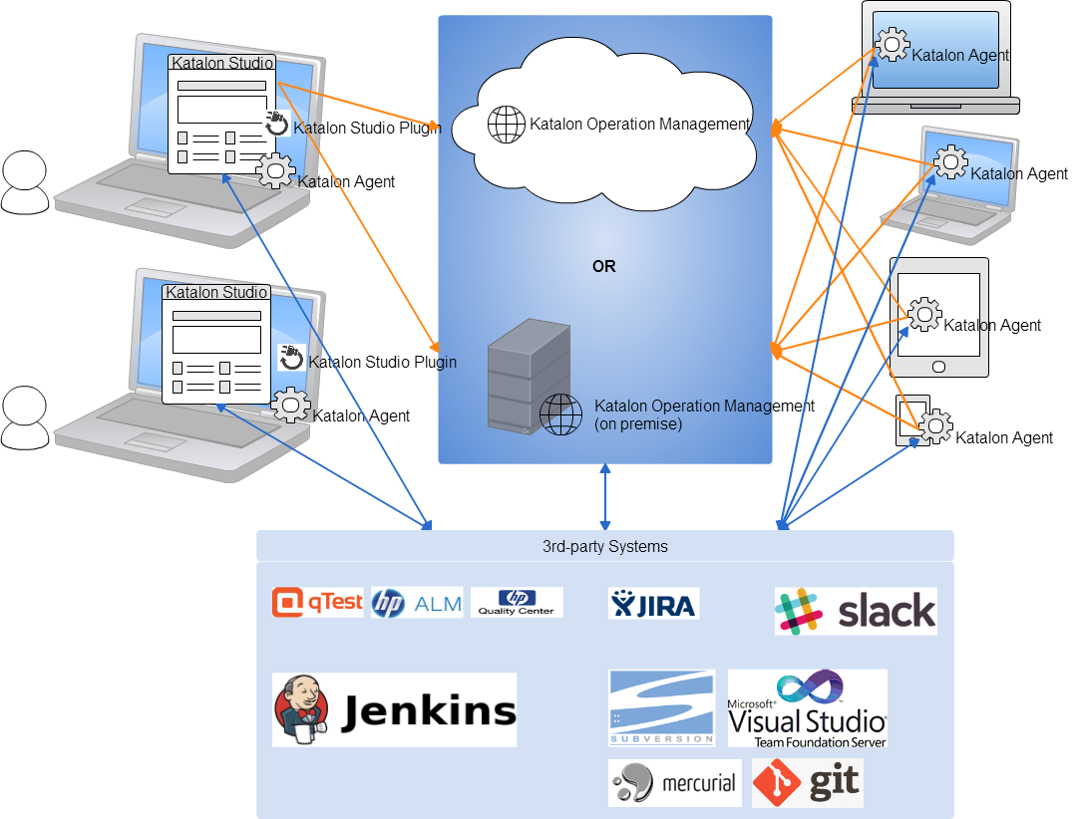

## Product Features

The following diagram depicts all the components and their relationship within Katalon platform:

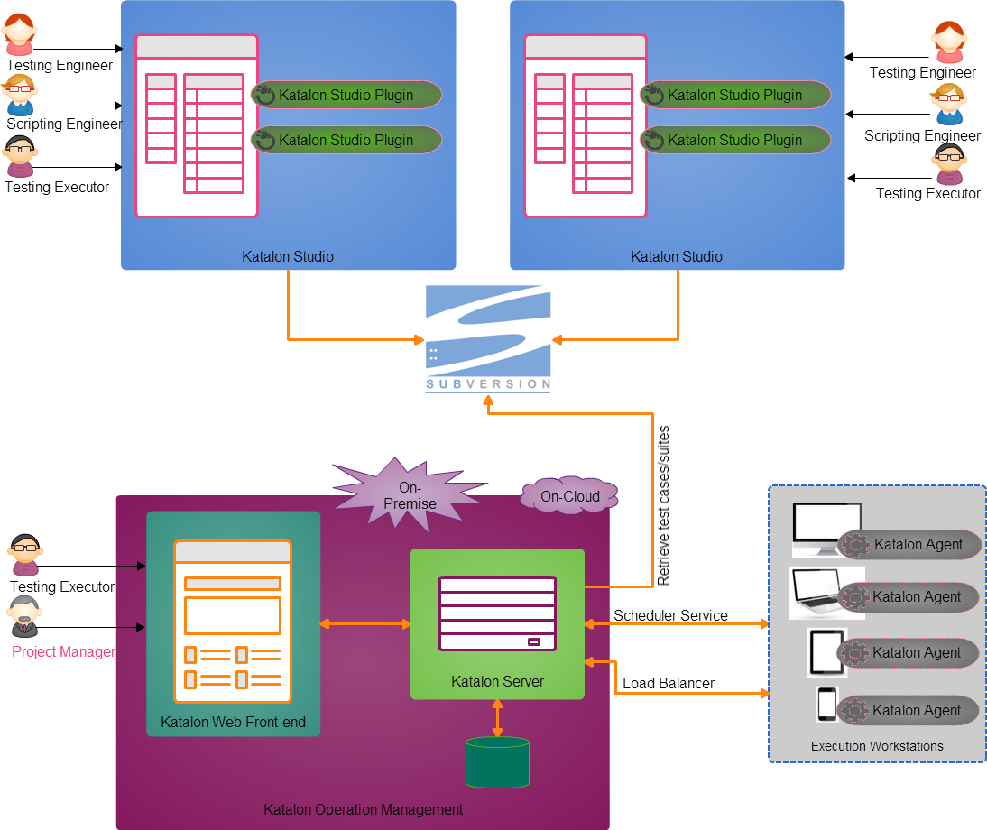

And the following diagrams illustrate the features of each component:

**Katalon Studio:**

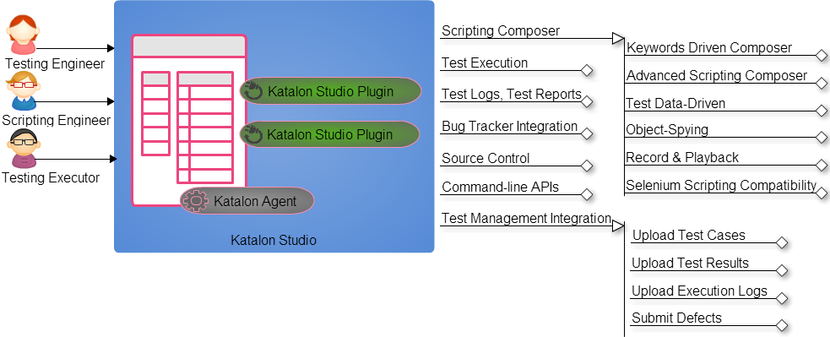

**Katalon Agent:**

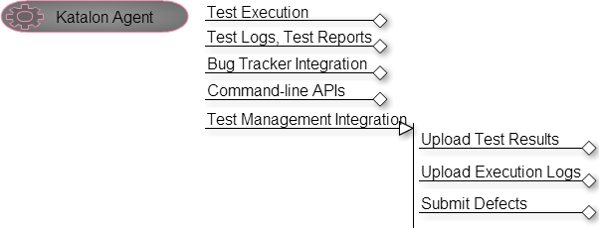

**Katalon Studio Plugins:**

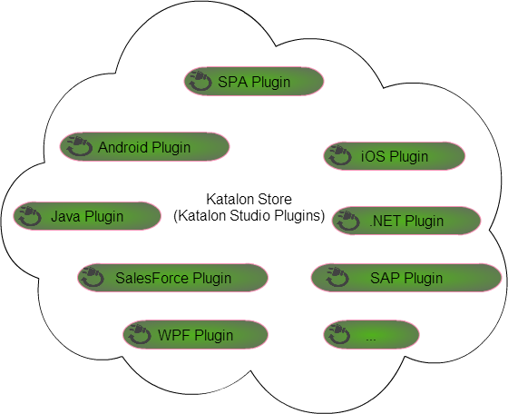

**Katalon Operation Management:**

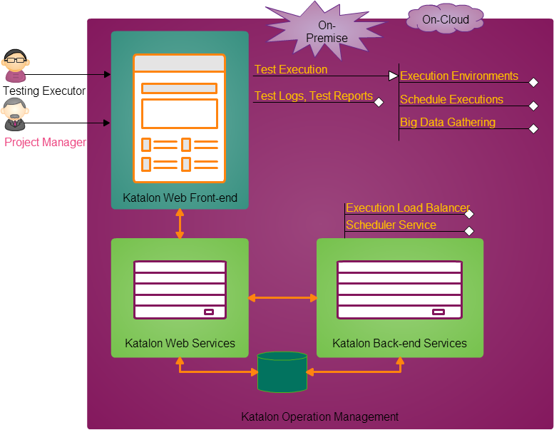

# System Constraints

## Supported OSes

* Workstation machine can be of any Oses which has Java VM JDK 6.0+

## Supported Hardware

* Workstation machine: PC/Laptop 4GB RAM as minimal, 1G free space on HDD

# Distribution Model & Monetization

It is currently the expectation that Katalon will be a product of KMS Technology that can be sold as part of consulting engagements, delivered via licensing models, and distributed under open source model as a way to rapidly increase the ease of automation in the automation testing field.

Firstly, Katalon Studio and Katalon Agent will be distributed under open source model to attract users. The purpose of this is to build up a customer space for Katalon platform. Once the number of users attracted is large enough and a stable customer space is built, release the other two components to market under subscription/license based model.

In summary, Katalon platform will be distributed as following:

* Katalon Studio
  + Distribute to the community as open source
* Katalon Agent
  + Distribute to the community as open source
* Katalon Studion Plugins
  + Perpetual license after acquiring from Katalon Store
* Katalon Operation Management
  + On-cloud with subscription based (user & time) license
  + On-premise with ??-based license
  + This component will be targeted to those organizations that are financial solution providers (such as delivering banking, insurance, financial services) and want to improve the quality and effectiveness of their software testing processes leading to quicker time-to-market products/services/solutions.

Revision History

|  |  |  |  |  |
| --- | --- | --- | --- | --- |
| Ver. | Date | Description of Change | Author | Approved by |
| 0.1 | 07/15/2014 | First draft | Phong Bui |  |
| 0.2 | 07/18/2014 | Added more features | Phong Bui |  |
| 0.5 | 07/22/2014 | Added Differentiation, Embedded objects | Hieu Phan |  |
| 1.0 | 07/22/2014 | Added Product Overview, Technology Stack | Phong Bui |  |
| 1.1 | 06/05/2015 | Revised product name and added core features | Brian Bernknopf |  |
| 1.2 | 06/14/2015 | Revised the entire docs based on the new distribution models and monetize strategies | Thu Tran |  |
| 1.3 | 06/15/2015 | Added more features for Enterprise | Phong Bui |  |
| 1.4 | 07/23/2015 | * Revised all the diagrams based on the feedback received after meeting with Vu Lam and Buu Nguyen. * Revised the distribution model for Katalon Studio and Katalon Agent. * “Katalon Enterprise” is renamed to “Katalon Operation Management”. | Thu Tran |  |